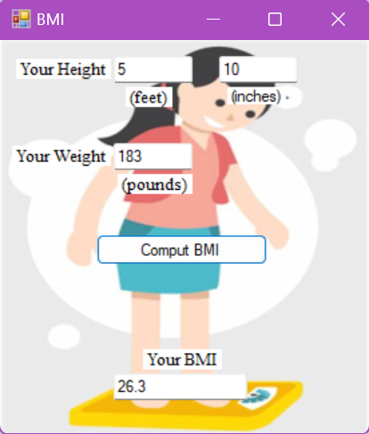
using System;
using System.Collections.Generic;
using System.ComponentModel;
using System.Data;
using System.Drawing;
using System.Linq;
using System.Text;
using System.Threading.Tasks;
using System.Windows.Forms;

/* BMI Calculator

The user will see a windows application form and be asked to input their height and weight.
Once they input their height and weight, the "Compute BMI" button does the following:

If user gives appropriate height and weight measurements
print BMI
else
print "Error"

more detail:

Your Height:______ ________
(feet) (inches)
Your weight:________
(pounds)

[Compute BMI]

Your BMI
________

*/

namespace WindowsFormsApp2
{
public partial class Form1 : Form
{
public Form1()
{
InitializeComponent();
}

private void textBox4_TextChanged(object sender, EventArgs e)
{

}

private void Form1_Load(object sender, EventArgs e)
{

}

private void button1_Click(object sender, EventArgs e)
{

double weight, bmi, heightF, heightI, total_inches, val;

bool weightCheck = double.TryParse(textBox3.Text,out val);
bool inchCheck = double.TryParse(textBox2.Text, out val);
bool feetCheck = double.TryParse(textBox1.Text, out val);

if (weightCheck && inchCheck && feetCheck)
{

}
heightF = Convert.ToDouble(textBox1.Text);
heightI = Convert.ToDouble(textBox2.Text);
weight = Convert.ToDouble(textBox3.Text);

total_inches = heightF * 12 + heightI;

if ((0 <= heightF)&&(heightF <= 12)&&((0 <= heightI)&&(heightI <= 12))&&(weight>0)){

bmi = (weight / Math.Pow(total_inches, 2)) * 703;
bmi = Math.Round(bmi, 1);
string bmiout = Convert.ToString(bmi);
textBox4.Text = bmiout;

}
else
{
textBox4.Text = "ERROR!";
}
}
}
}

